Name: Mukwaya Lwere
Class: CS 79B
Assignment 2: Deploying EC2 with EBS
Date: 11/7/2026
Launch EC2 Instance & Configure EBS Storage
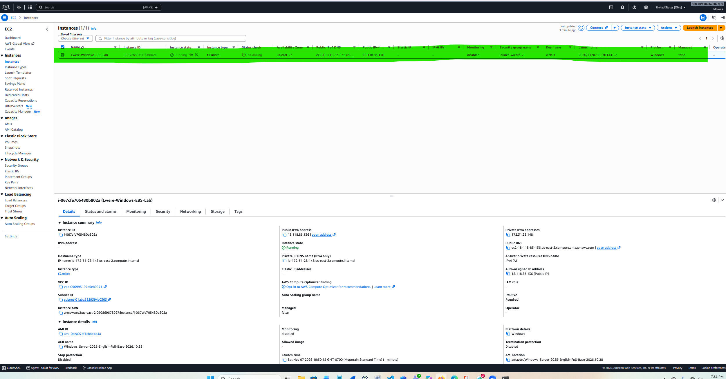
Connect to the Windows Server via RDP
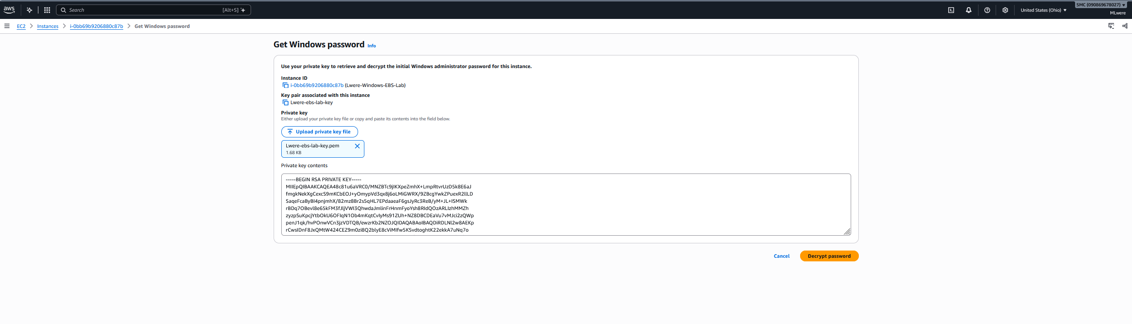
Administrator
;MY1*@HD6U8owEV$?S)7MK8!8yP(WY@4
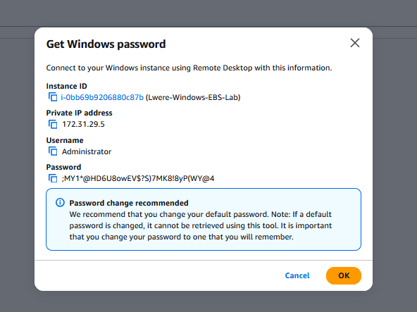
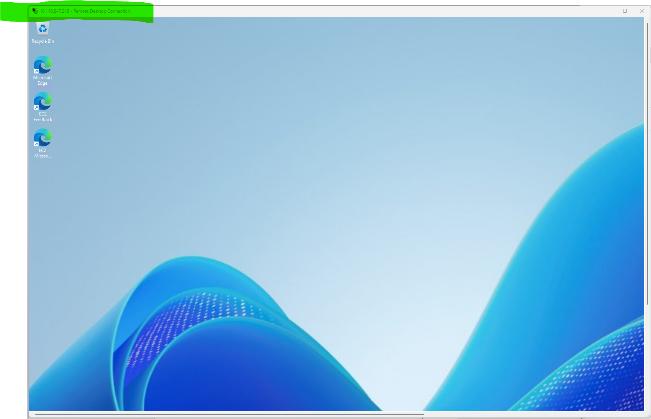

Bring Disks Online, Initialize, and Format
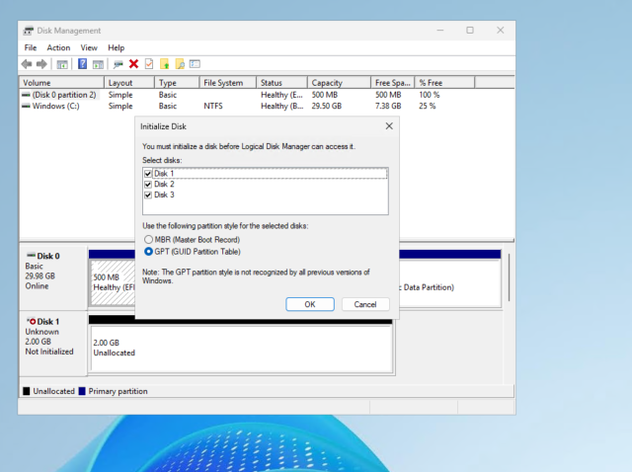
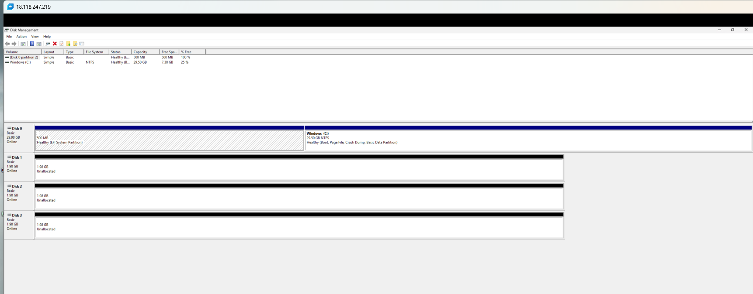
Format the partitions:


